

17. Sorting Lists with Different Cases
CODE:
def sortList(nums):
return sorted(nums)
print(sortList([]))
print(sortList([1]))
print(sortList([7, 7, 7, 7]))
print(sortList([-5, -1, -3, -2, -4]))

OUTPUT:
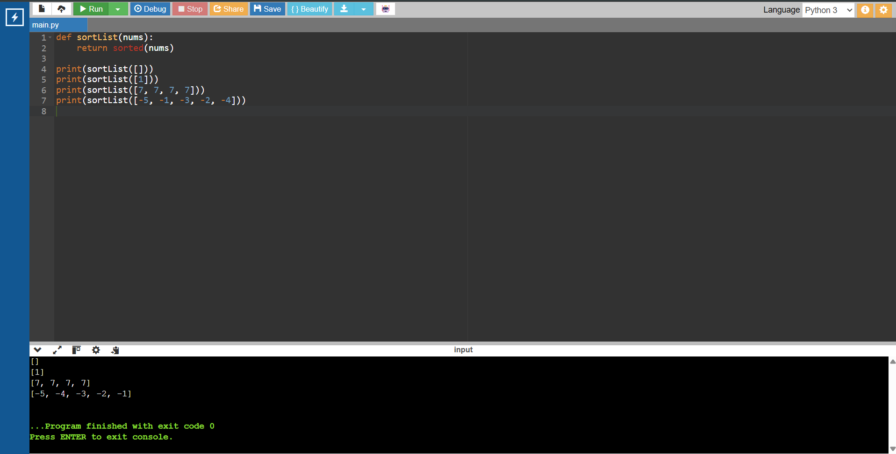

18. Selection Sort
CODE:
def selectionSort(arr):
n = len(arr)
for i in range(n):
min_index = i
for j in range(i + 1, n):
if arr[j] < arr[min_index]:
min_index = j
arr[i], arr[min_index] = arr[min_index], arr[i]
return arr
print(selectionSort([5, 2, 9, 1, 5, 6]))
print(selectionSort([10, 8, 6, 4, 2]))
print(selectionSort([1, 2, 3, 4, 5]))

OUTPUT:
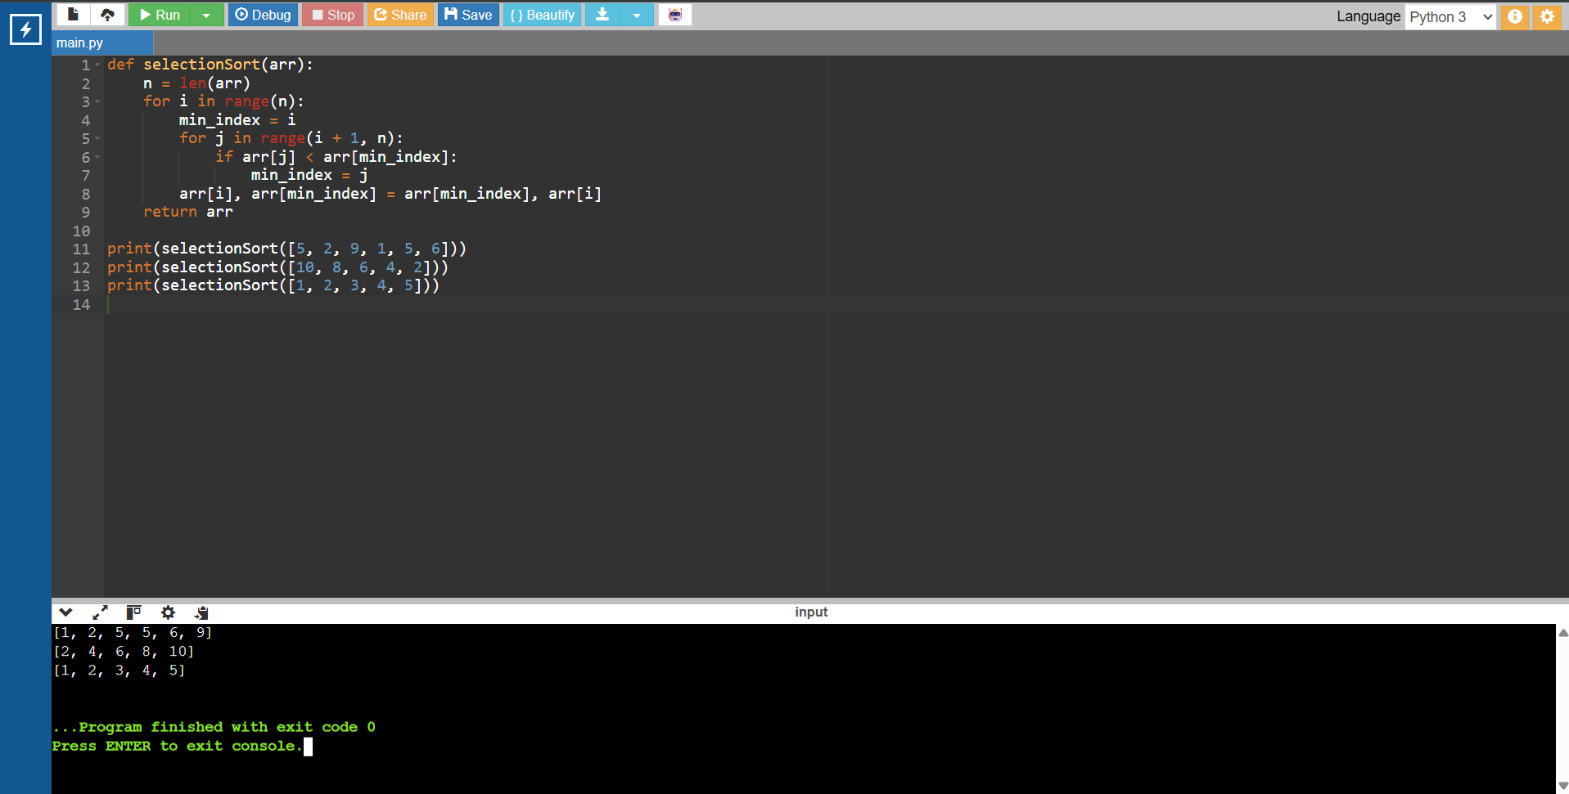

19. Optimized Bubble Sort
CODE:
def bubble_sort(arr):
n = len(arr)
for i in range(n):
swapped = False
for j in range(n - i - 1):
if arr[j] > arr[j + 1]:
arr[j], arr[j + 1] = arr[j + 1], arr[j]
swapped = True
if not swapped:
break
return arr
print(bubble_sort([64, 25, 12, 22, 11]))
print(bubble_sort([29, 10, 14, 37, 13]))
print(bubble_sort([3, 5, 2, 1, 4]))
print(bubble_sort([1, 2, 3, 4, 5]))
print(bubble_sort([5, 4, 3, 2, 1]))

OUTPUT:
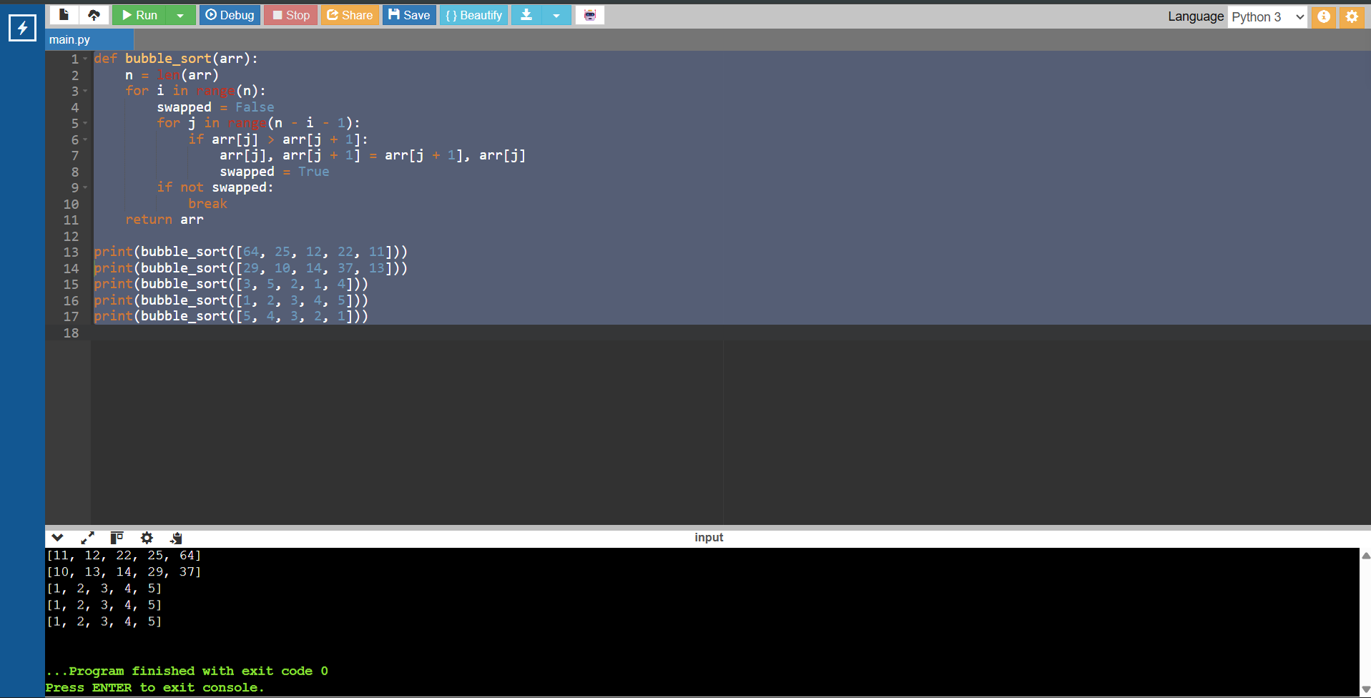

\

20. Insertion Sort with Duplicate Elements
CODE:
def insertionSort(arr):
for i in range(1, len(arr)):
key = arr[i]
j = i - 1
while j >= 0 and arr[j] > key:
arr[j + 1] = arr[j]
j -= 1
arr[j + 1] = key
return arr
print(insertionSort([3, 1, 4, 1, 5, 9, 2, 6, 5, 3]))
print(insertionSort([5, 5, 5, 5, 5]))
print(insertionSort([2, 3, 1, 3, 2, 1, 1, 3]))

OUTPUT:
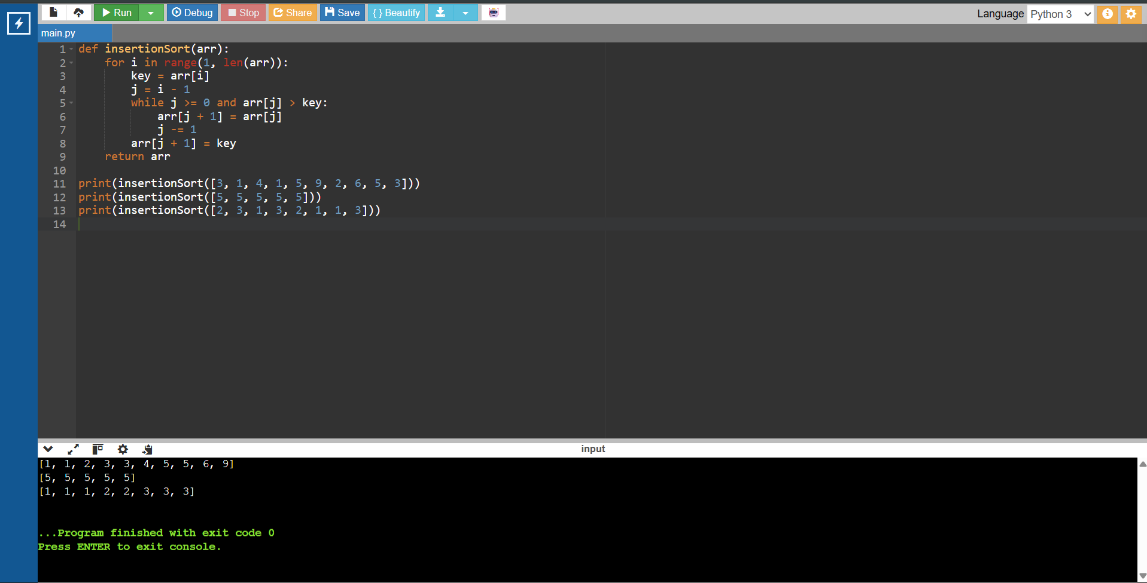

21. Kth Missing Positive Number
CODE:
def findKthPositive(arr, k):
missing = 1
i = 0
while k > 0:
if i < len(arr) and arr[i] == missing:
i += 1
else:
k -= 1
if k == 0:
return missing
missing += 1
print(findKthPositive([2, 3, 4, 7, 11], 5))
print(findKthPositive([1, 2, 3, 4], 2))

OUTPUT:
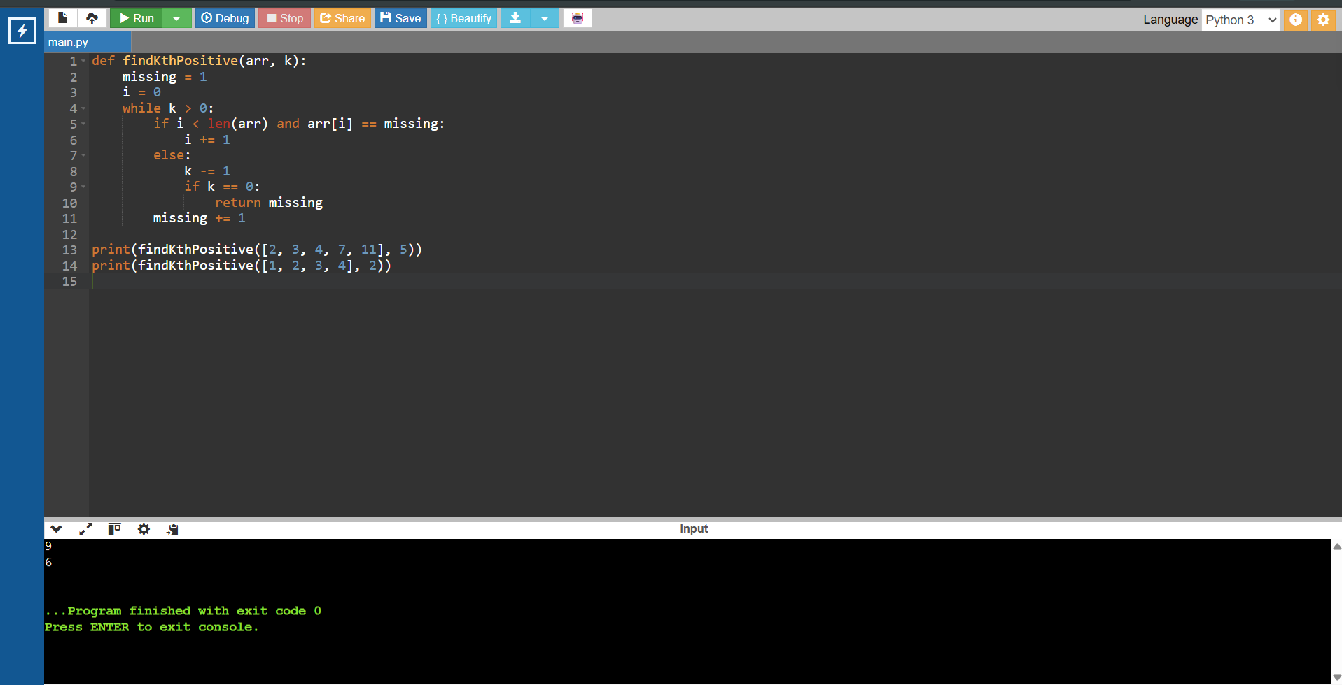

22. Find Peak Element Using Binary Search
CODE:
def findPeakElement(nums):
low, high = 0, len(nums) - 1
while low < high:
mid = (low + high) // 2
if nums[mid] < nums[mid + 1]:
low = mid + 1
else:
high = mid
return low
print(findPeakElement([1, 2, 3, 1]))
print(findPeakElement([1, 2, 1, 3, 5, 6, 4]))

OUTPUT:
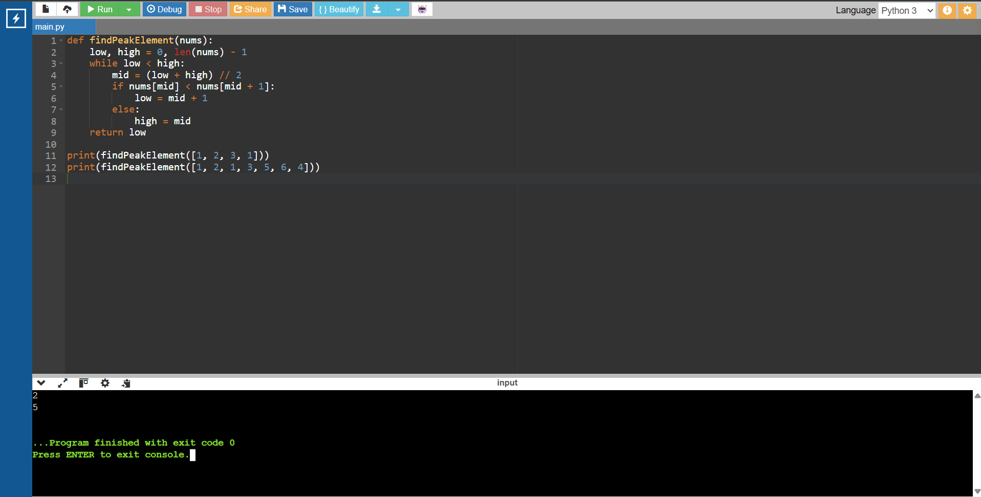

23. First Occurrence of a Substring
CODE:
def strStr(haystack, needle):
for i in range(len(haystack) - len(needle) + 1):
if haystack[i:i + len(needle)] == needle:
return i
return -1
print(strStr("sadbutsad", "sad"))
print(strStr("leetcode", "leeto"))

OUTPUT:
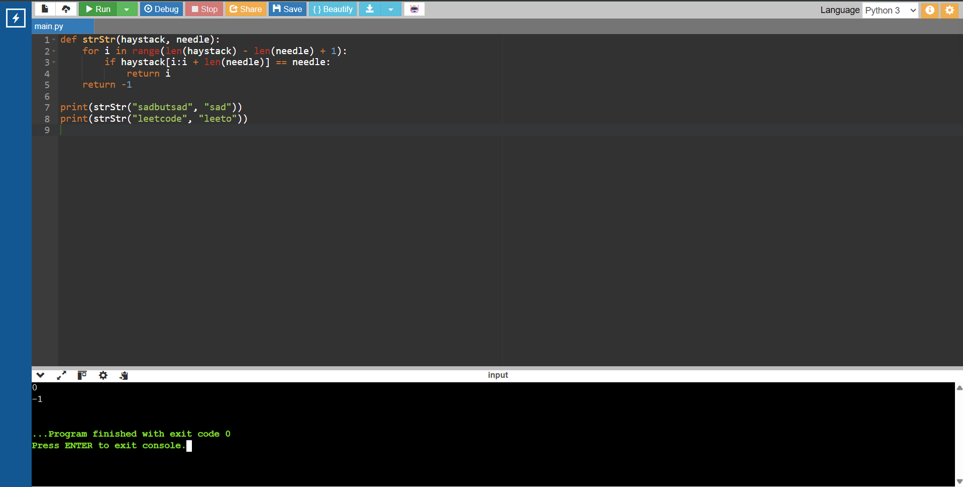

24. Find Strings That Are Substrings of Other Words
CODE:
def stringMatching(words):
result = []
for word in words:
for other in words:
if word != other and word in other:
result.append(word)
break
return result
print(stringMatching(["mass", "as", "hero", "superhero"]))
print(stringMatching(["leetcode", "et", "code"]))
print(stringMatching(["blue", "green", "bu"]))

OUTPUT:
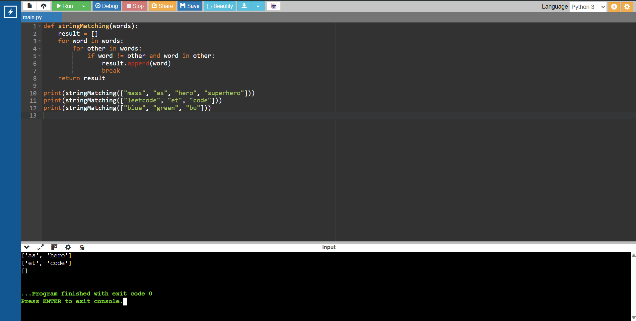

25. Closest Pair of Points (Brute Force)
CODE:
import math
def closestPair(points):
min_dist = float("inf")
pair = None
for i in range(len(points)):
for j in range(i + 1, len(points)):
d = math.dist(points[i], points[j])
if d < min_dist:
min_dist = d
pair = (points[i], points[j])
return pair, min_dist
points = [(1, 2), (4, 5), (7, 8), (3, 1)]
pair, distance = closestPair(points)
print("Closest pair:", pair[0], "-", pair[1])
print("Minimum distance:", distance)

OUTPUT:
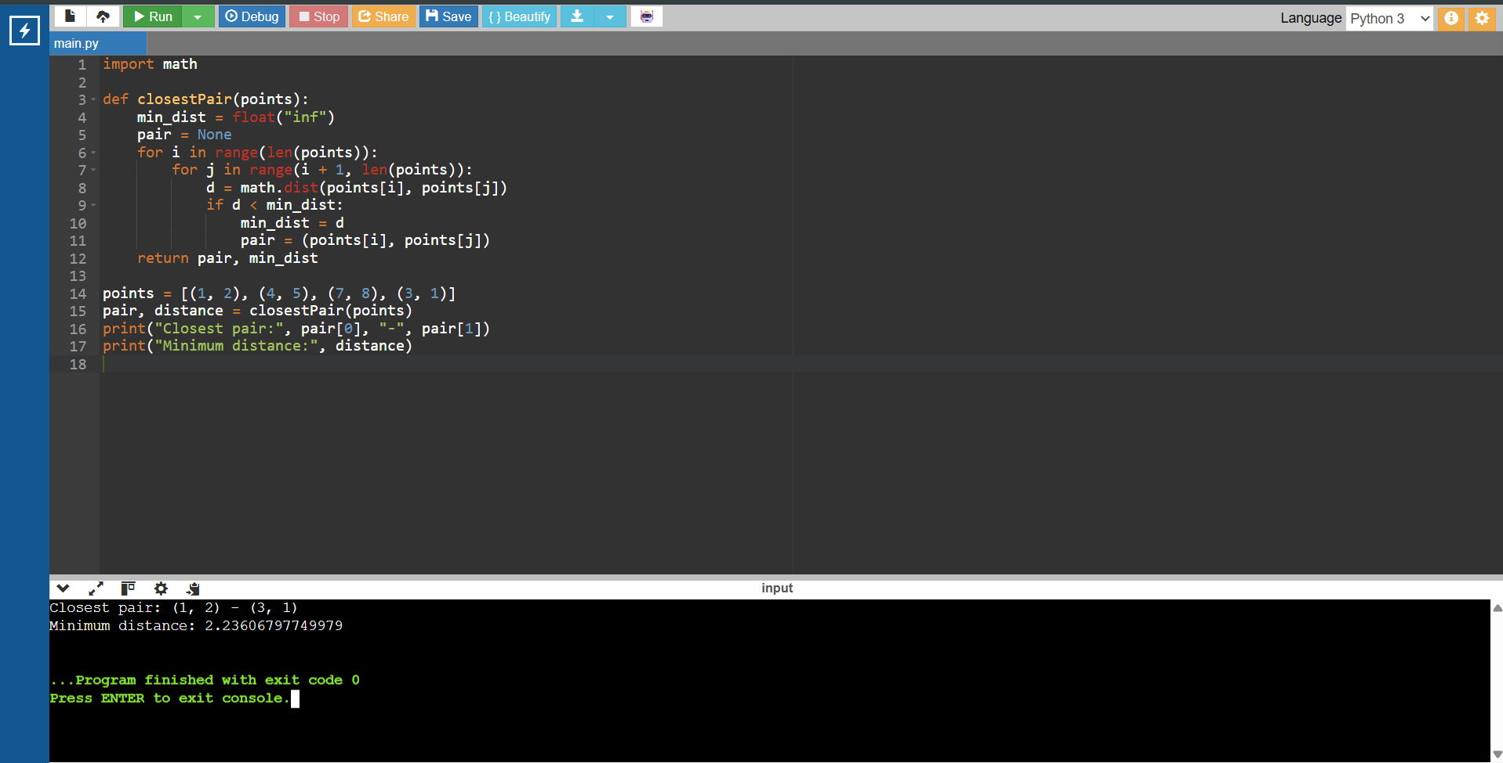

26. Brute Force Convex Hull for Given Points
CODE:
def convexHull(points):
hull = set()
n = len(points)
for i in range(n):
for j in range(i + 1, n):
left = right = False
for k in range(n):
if k == i or k == j:
continue
cross = ((points[j][0] - points[i][0]) *
(points[k][1] - points[i][1]) -
(points[j][1] - points[i][1]) *
(points[k][0] - points[i][0]))
if cross > 0:
left = True
elif cross < 0:
right = True
if not (left and right):
hull.add(points[i])
hull.add(points[j])
return sorted(hull)
points = [(10, 0), (11, 5), (5, 3), (9, 3.5),
(15, 3), (12.5, 7), (6, 6.5), (7.5, 4.5)]
print("Convex Hull:", convexHull(points))

OUTPUT:


27. Convex Hull of 2D Points
CODE:
def convexHull(points):
hull = set()
n = len(points)
for i in range(n):
for j in range(i + 1, n):
left = right = False
for k in range(n):
if k == i or k == j:
continue
cross = ((points[j][0] - points[i][0]) *
(points[k][1] - points[i][1]) -
(points[j][1] - points[i][1]) *
(points[k][0] - points[i][0]))
if cross > 0:
left = True
elif cross < 0:
right = True
if not (left and right):
hull.add(points[i])
hull.add(points[j])
return sorted(hull)
points = [(1, 1), (4, 6), (8, 1), (0, 0), (3, 3)]
print("Convex Hull:", convexHull(points))

OUTPUT:
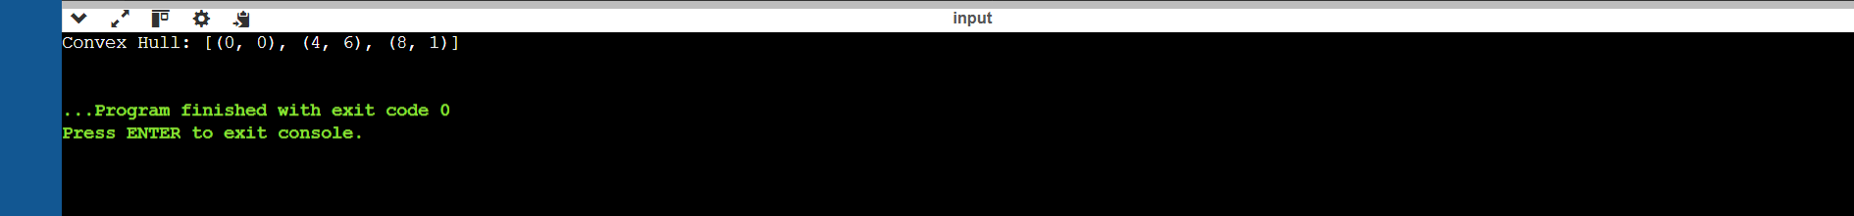

28. Travelling Salesperson Problem (Exhaustive Search)
CODE:
from itertools import permutations
from math import dist
def tsp(cities):
start = cities[0]
best_path = None
best_distance = float("inf")
for order in permutations(cities[1:]):
path = [start] + list(order) + [start]
total = sum(dist(path[i], path[i + 1]) for i in range(len(path) - 1))
if total < best_distance:
best_distance = total
best_path = path
return best_distance, best_path
cities1 = [(1, 2), (4, 5), (7, 1), (3, 6)]
cities2 = [(2, 4), (8, 1), (1, 7), (6, 3), (5, 9)]
for cities in [cities1, cities2]:
distance, path = tsp(cities)
print("Shortest Distance:", distance)
print("Shortest Path:", path)

OUTPUT:
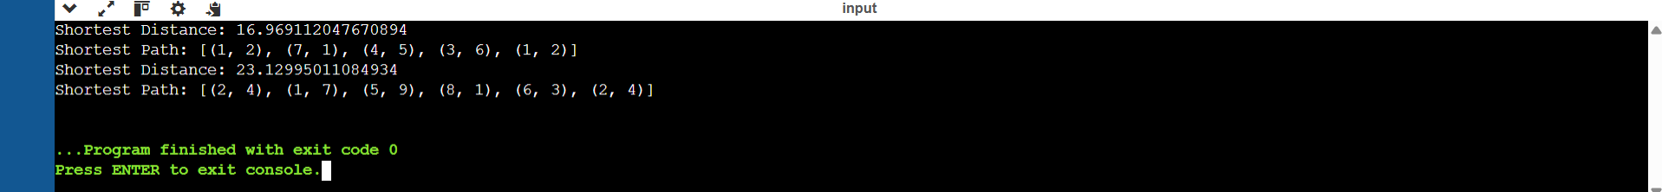

29. Assignment Problem (Exhaustive Search)
CODE:
from itertools import permutations
def assignment_problem(cost_matrix):
n = len(cost_matrix)
best_cost = float("inf")
best_assignment = None
for tasks in permutations(range(n)):
total = sum(cost_matrix[i][tasks[i]] for i in range(n))
if total < best_cost:
best_cost = total
best_assignment = tasks
pairs = [(i + 1, best_assignment[i] + 1) for i in range(n)]
return pairs, best_cost
cost1 = [[3, 10, 7], [8, 5, 12], [4, 6, 9]]
cost2 = [[15, 9, 4], [8, 7, 18], [6, 12, 11]]
print("Optimal Assignment and Total Cost:", assignment_problem(cost1))
print("Optimal Assignment and Total Cost:", assignment_problem(cost2))

OUTPUT:
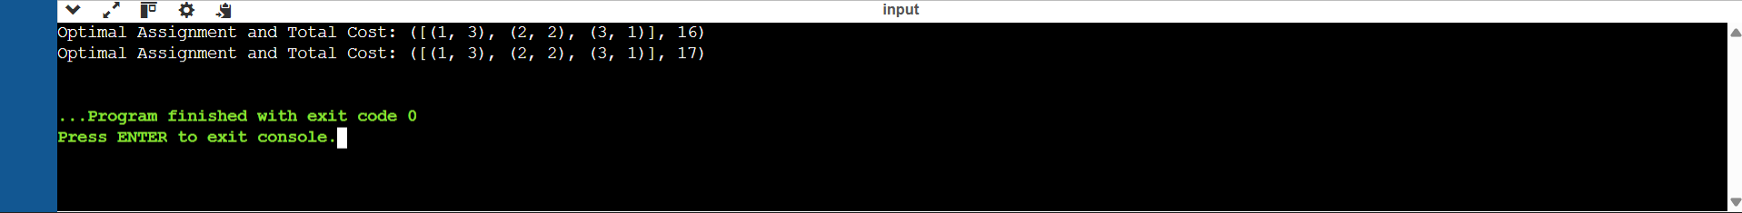

30. 0-1 Knapsack Problem (Exhaustive Search)
CODE:
from itertools import combinations
def knapsack(weights, values, capacity):
n = len(weights)
best_value = 0
best_items = []
for r in range(n + 1):
for items in combinations(range(n), r):
weight = sum(weights[i] for i in items)
value = sum(values[i] for i in items)
if weight <= capacity and value > best_value:
best_value = value
best_items = list(items)
return best_items, best_value
print(knapsack([2, 3, 1], [4, 5, 3], 4))
print(knapsack([1, 2, 3, 4], [2, 4, 6, 3], 6))

OUTPUT:


